

**Engineers.**

Engineers apply scientific principles to analyze, design, invent, code, build, and create to solve all sorts problems and make the world a better place. One of their most important tools is their own creativity.

A professional engineer is competent by virtue of his/her fundamental education and training to apply the scientific method and outlook to the analysis and solution of engineering problems. He/she is able to assume personal responsibility for the development and application of engineering science and knowledge, notably in research, design, construction, manufacturing, superintending, managing, and in the education of the engineer. His/her work is predominantly intellectual and varied and not of a routine mental or physical character. It requires the exercise of original thought and judgment and the ability to supervise the technical and administrative work of others. His/her education will have been such as to make him/her capable of closely and continuously following progress in his/her branch of engineering science by consulting newly published works on a worldwide basis, assimilating such information, and applying it independently. He/she is thus ve been such that he/she will have acquired a broad and general appreciation of the engineering sciences as well as thorough insight into the special features of his/her own branch. In due time he/she will be able to give authoritative technical advice and assume responsibility for the direction of important tasks in his/her branch.



Chemical engineer

Chemical engineers develop and design chemical manufacturing processes. Chemical engineers apply the principles of chemistry, physics, and engineering to design equipment and processes for manufacturing products such as gasoline, detergents, and paper.



Civil Engineers

Civil engineers plan, design, and supervise the construction and maintenance of building and infrastructure projects. These projects may include facilities, bridges, roads, tunnels, and water and sewage systems



System engineers

A System Engineer does not perform the coding. They manage installed systems and infrastructure. A Software Engineer spends all day doing coding. System Engineers study Mathematics, Engineering, and Computer Science.



Mechanical Engineer

Mechanical engineers design, develop, build, and test. They deal with anything that moves, from components to machines to the human body. The work of mechanical engineers plays a crucial role in shaping the technology and infrastructure that drive our modern world. ELECTRICAL ENGINEER



An electrical engineer specialises in building, testing, installing, and maintaining electrical equipment and systems. Electrical and electronics engineers design, develop, upgrade, and maintain electrical systems and equipment.

Environmental engineers typically do the following: Prepare, review, update, and present reports on issues related to the environment. Design systems that protect the environment, such as those to reclaim water or to control air pollution. Obtain, update, and maintain plans, permits, and standard operating procedures

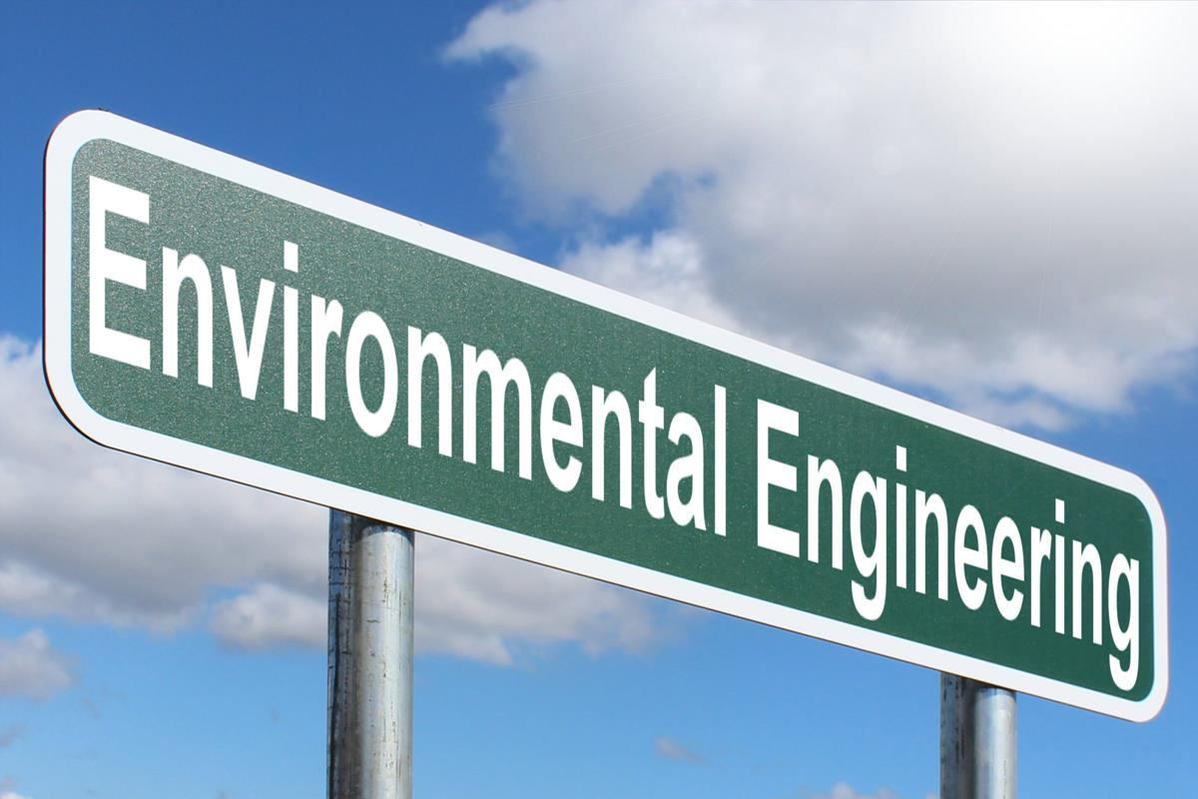

Computer Engineer



Computer engineering (CoE or CpE) is a branch of computer science and electronic engineering that integrates several fields of computer science and electronic engineering required to develop computer hardware and software. Computer engineering is referred to as computer science and engineering at some universities

Aerospace engineers design, develop, and test aircraft, spacecraft, satellites, and missiles. In addition, they create and test prototypes to make sure that they function according to design



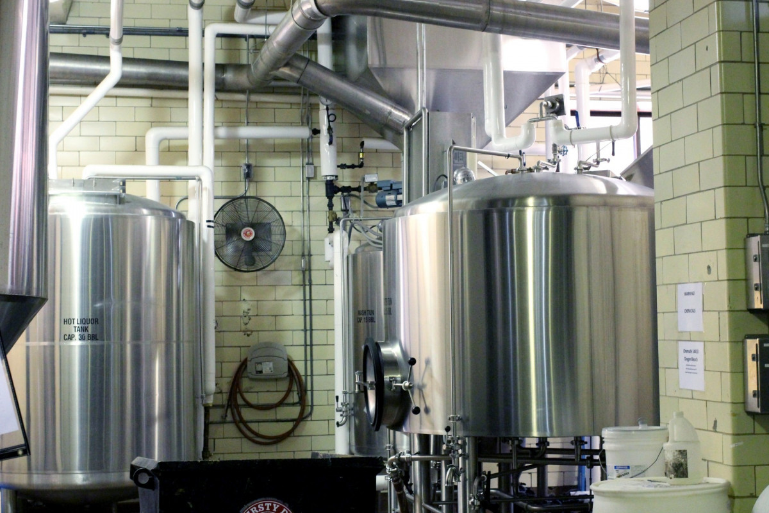

Industrial Engineer

Industrial engineering is an engineering profession that is concerned with the optimization of complex processes, systems, or organizations by developing, improving and implementing integrated systems of people, money, knowledge, information and equipment. Industrial engineering is central to manufacturing operations.

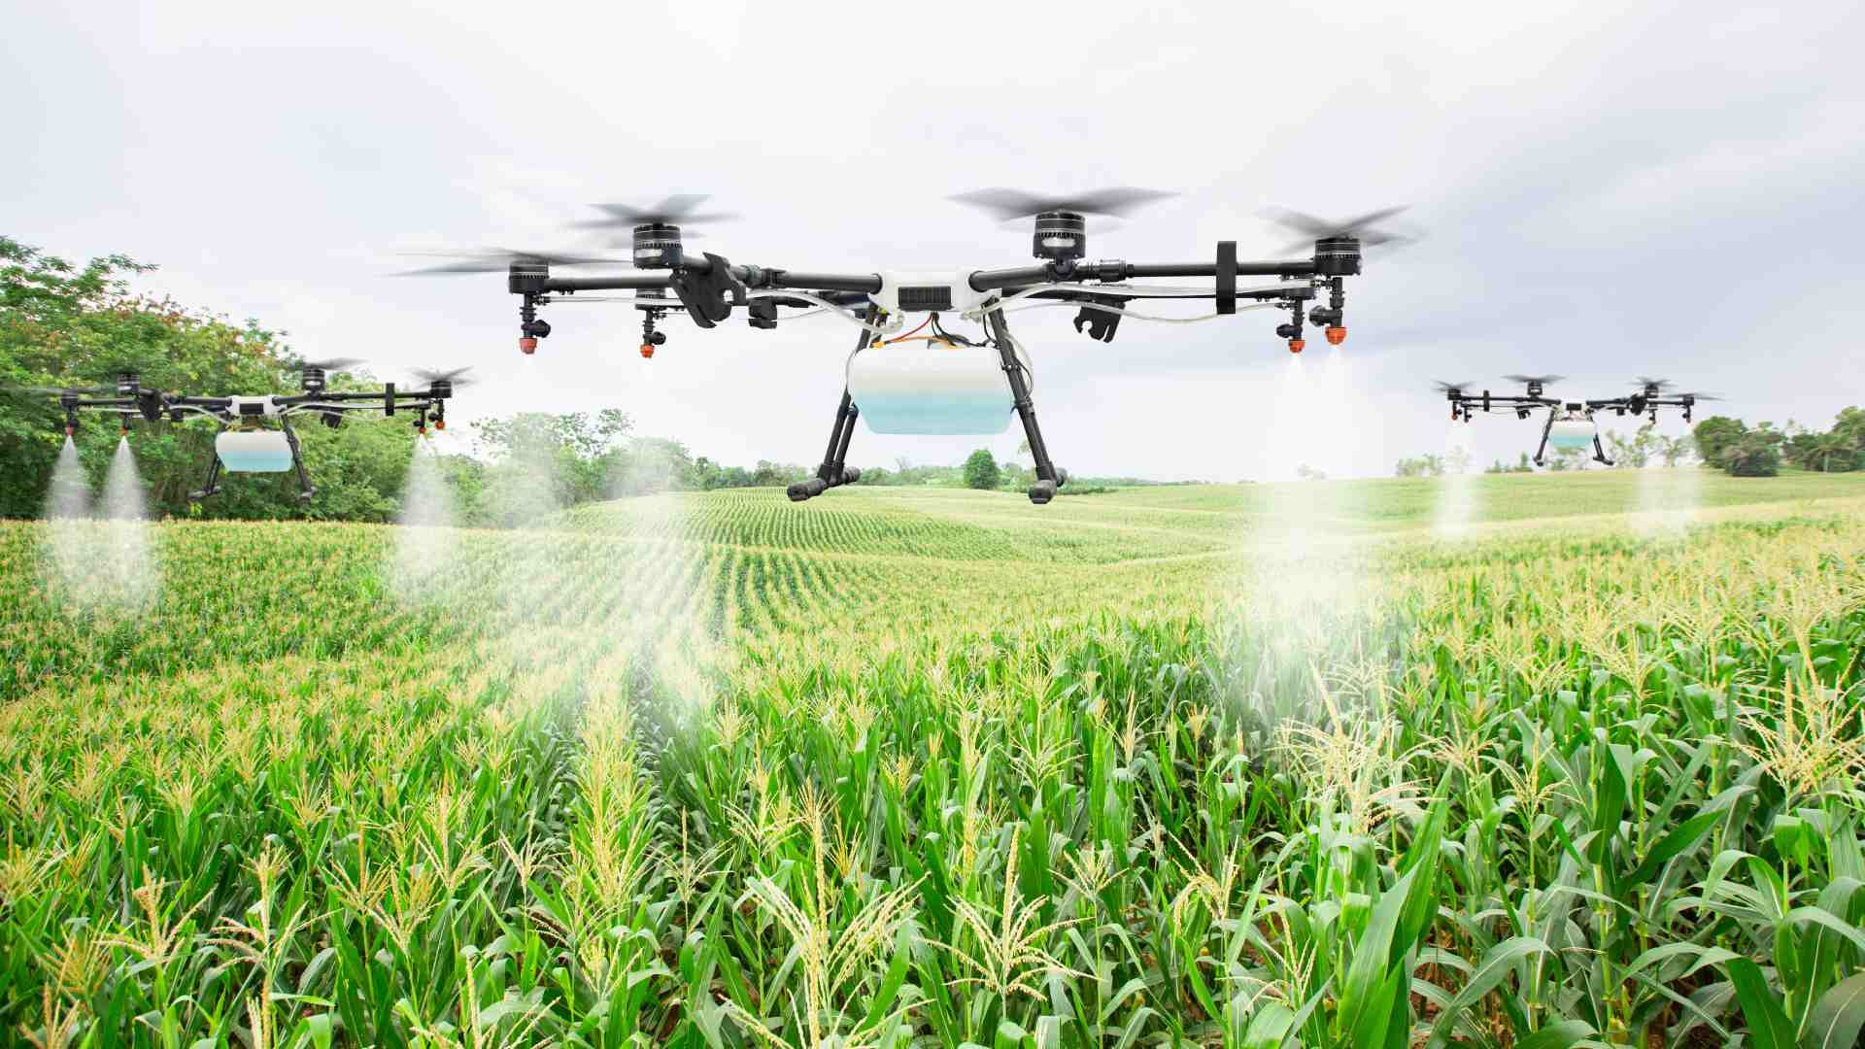

Agricultural Engineer

Agricultural engineering, also known as agricultural and biosystems engineering, is the field of study and application of engineering science and designs principles for agriculture purposes, combining the various disciplines of mechanical, civil, electrical, food science, environmental, software, and chemical ...

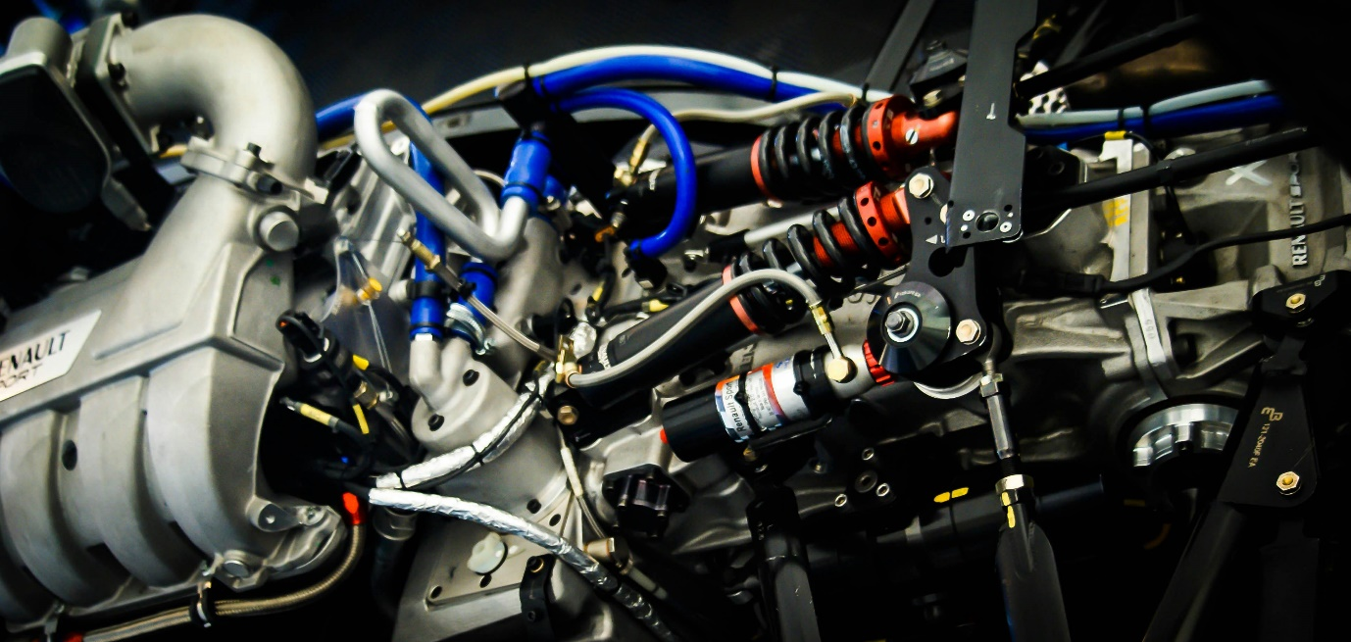

Automobile Engineer

Automotive engineering is a branch of vehicle engineering that focuses on the application, design and manufacture of various types of automobiles. This field of engineering involves the direct application of mathematics and physics concepts in the design and production of vehicles.